|  |  |
| --- | --- |
| C:\Users\Richard\Documents\Family Tree Maker\Book Material - Wolfe\Pics from Judie List (trip) - processed\129a-c.jpg  Jo Ann Marilyn Clark List Leatherwood – about 2003 (est.) | C:\Users\Richard\Documents\Family Tree Maker\Book Material - Wolfe\Album Pictures\Jan and Ronald List-2.jpg  Janette “Jan” Koch Comstock and  Ronald Luther List – about 2000 (est.) |
|  |  |

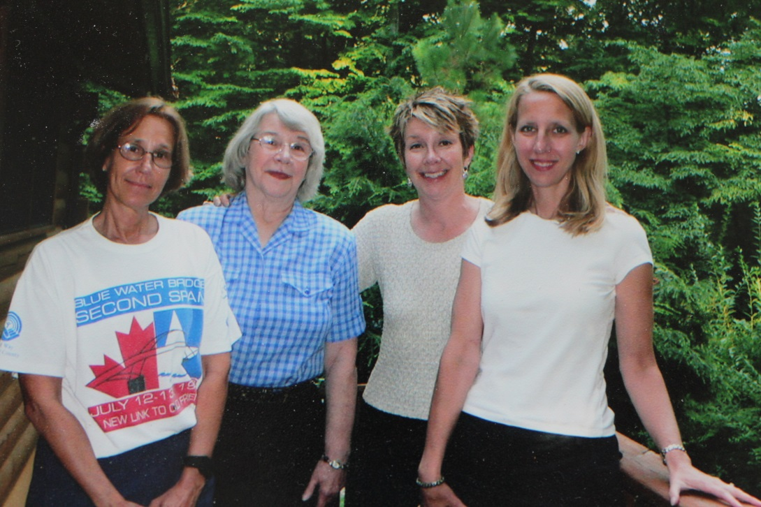

Susan Jo, Jo Ann, Marilyn and Judie – August 2005